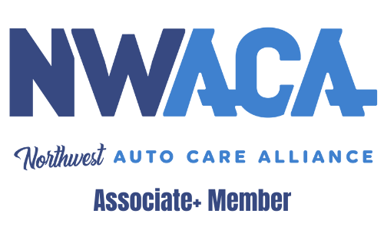
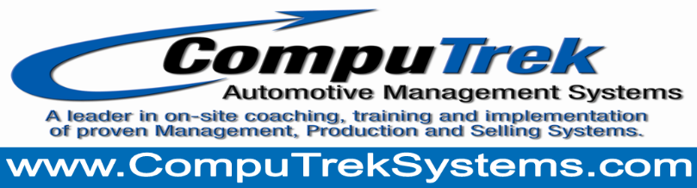

NWACA Member CompuTrek Benefits

CompuTrek has been helping Auto Repair Centers gain on average $373,000 in NEW Gross Profit Dollars in a 12-month period since 2006 from our coaching and training packages! We help you build, lead, manage, and empower your team to greater results.

We support NWACA by offering members several complimentary values just for being members.
- With the purchase of any of our coaching and training packages receive an NWACA Annual Membership Dues credit of $350.

- Complimentary 60 minutes of live CompuTrek Coaching each month via online NWACA Group Membership webinar. Real topics with Real Solutions. Typically the Third Tuesday of each month at Noon Pacific Time. A $350 Value.

- Complimentary Level 1 Shop evaluation of Sales, Gross Profits, Tech Efficiency, and more with three or more takeaways to implement right away to bring an increase. A $1,500 Value!

- Complementary E-Book by Coach Dave Overcoming Customer Objections. A $55 Value!

- CompuTrek Full Labor Rate Developer Tool normally $249 NWACA Member Price $149. Save $100.

Four Member Benefits totaling $2,355!

“Every champion was once a contender, intentional in their training."

To your success!

Dave

Dave Schedin, CEO
Master Coach, Former Shop Owner & Master Tech
"$373K/Yr. Avg GP Increase Last 30 Shops"
CompuTrek Automotive Solutions
253.732.5229
dave@computreksystems.com
www.computreksystems.com

