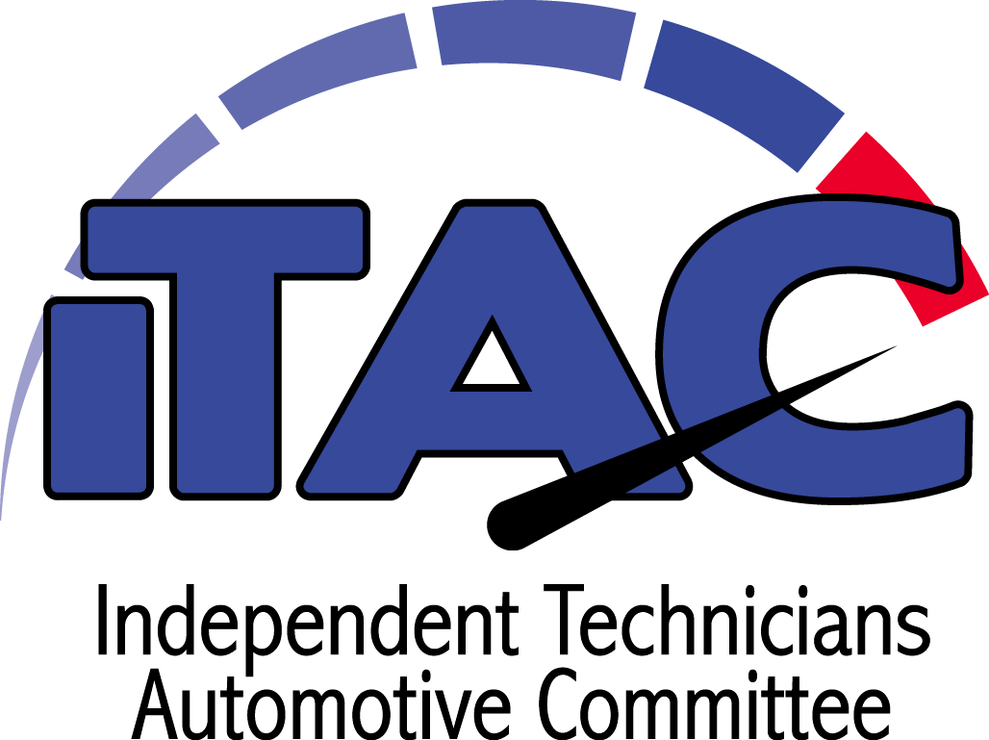
INVESTING IN THE NEXT GENERATION OF AUTOMOTIVE PROFESSIONALS
iTAC Apprenticeship Program · Sponsorship Packet

The automotive service industry is facing one of the largest technician shortages in its history.
The iTAC Apprenticeship Program is building the solution – a structured pathway that turns students into career-ready skilled automotive professionals.

What is iTAC?
A workforce development program that connects:
- Students & career explorers
- Technical education programs
- Real-world shop apprenticeships
Result: Highly trained technicians ready to contribute from day one.

Why Sponsor iTAC?
- Strengthen the industry workforce pipeline for automotive repair shops everywhere
- Invest in the long-term sustainability of independent automotive repair
- Demonstrate visible leadership in workforce development
- Align your brand with career development, mentorship, and education
- Build direct connections with the next generation of automotive professionals

Students &  Career Explorers | ▶ | Technical  Education | ▶ | iTAC  Program | ▶ | Professional  Technicians | ▶ | Industry Leaders  & Mentors

Your Impact
- Fund structured apprenticeship training in independent repair facilities
- Connect technical college students with real-world shop mentorship
- Develop the next generation of highly skilled automotive technicians
- Strengthen collaboration between educators, repair facilities, and industry partners
- Protect the future sustainability of the independent automotive service industry

Partnership Tiers
BENEFIT | $20,000  Premier | $10,000  Champion | $5,000  Partner | $2,500  Supporting | $1,500  Supporter
Exclusive Premier Sponsorship | Exclusive | — | — | — | —
iTAC Foundation Board Seat | Board Seat | — | — | — | —
Graduation Speaking Opportunity | Speaking | — | — | — | —
Co-Branded Impact Report | Lead Co-Brand | Recognition | — | — | —
Sponsor Video Feature | Produced | — | — | — | —
Annual Foundation Meeting | Included | — | — | — | —
ATE Booth Placement | Priority | Discounted | Discounted | — | —
On-Stage ATE Recognition | Premier Slide | Slide | Group | Group | —
Website Placement | Premier Banner | Featured | Standard | Linked | Linked
Newsletter Recognition | Quarterly | 2× / year | 1× / year | Group | Group
Social Media Exposure | Bi-Monthly | 4 Posts | 2 Posts | 1 Post | Name Only
ATE Scholarship Recognition | Prominent | Included | Included | — | —
Recognition on Certificates | Prominent | Placement | — | — | —
Introductions to Training Agents | Priority | Included | — | — | —
Official Sponsor Certificate | Framed | Certificate | Certificate | Certificate | Certificate
Custom Digital Sponsor Badge | Included | Included | Included | Included | Included
Annual Appreciation Recognition | Premier | Included | Included | Included | Included

What You Receive
- Industry-leading brand visibility  - Website & social exposure  - Exclusive partner benefits | - Industry event recognition  - Access to future technicians  - Alignment with workforce development initiatives

JOIN US
Build careers. Strengthen shops. Secure the future of the automotive industry.
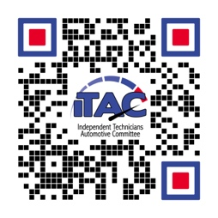
How to Pay
We Accept: Visa · Mastercard · American Express
iTAC Foundation
PO Box 99907
Lakewood, WA 98499

